1. can we add browser tested in test case level?

In Configuration level

1. ExtentSparkReporter spark = new ExtentSparkReporter("./sparkReports/result.html"); - showing error not able to import . Dependencies are added.

May be the jar files are not imported properly. Force update

Or Check the version of dependency

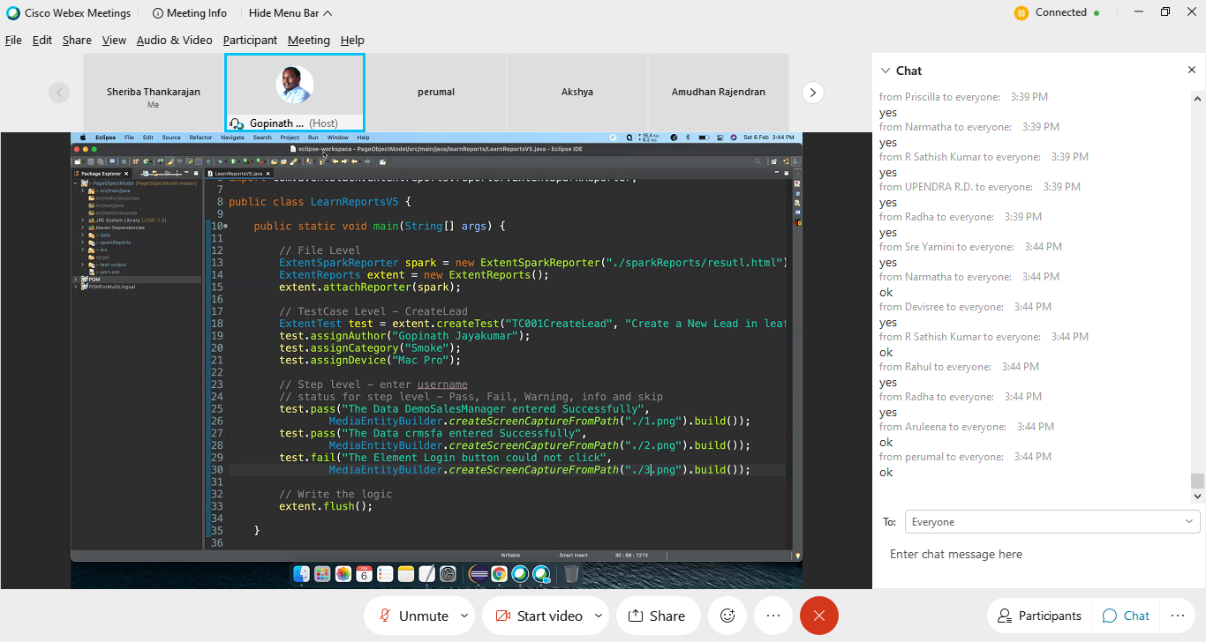

Same code.. But including annotations

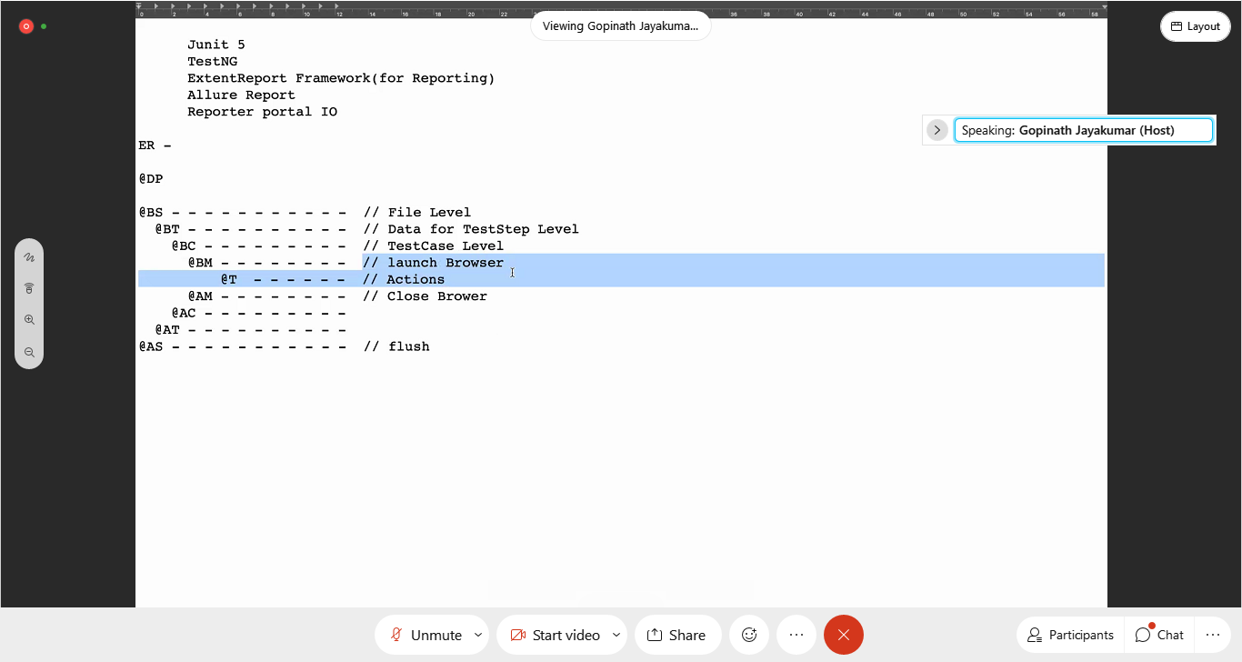

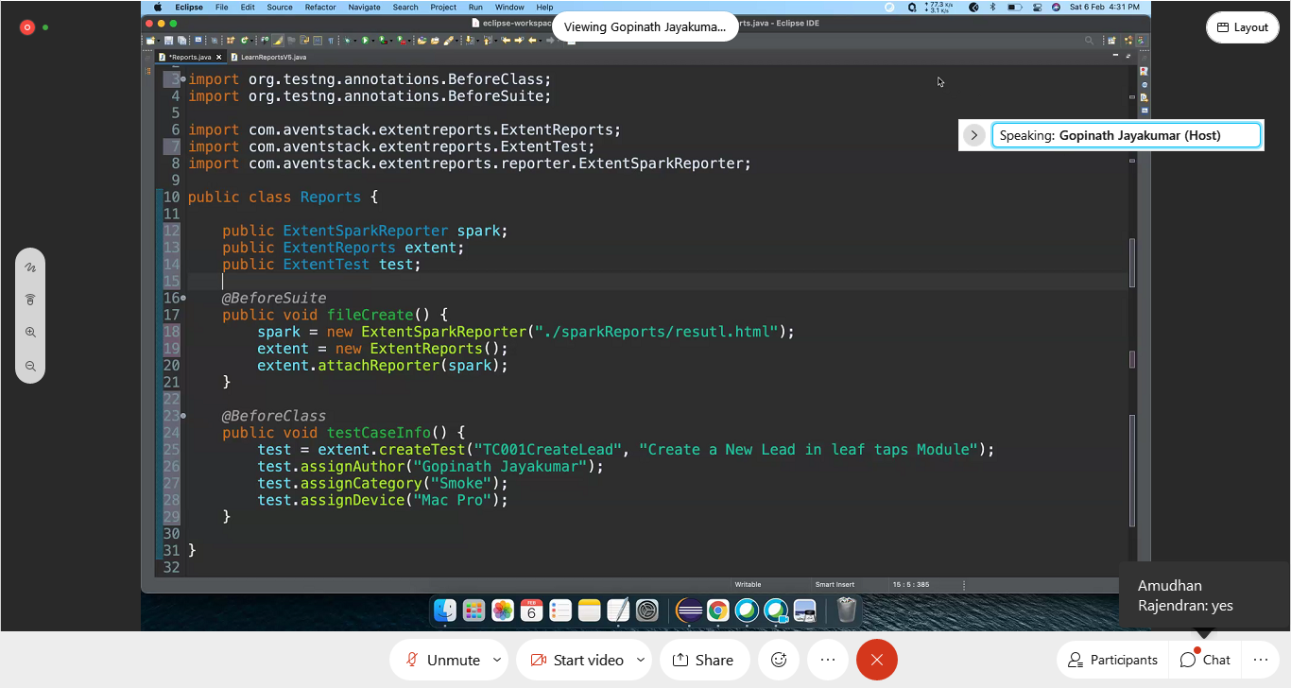

With parameters:

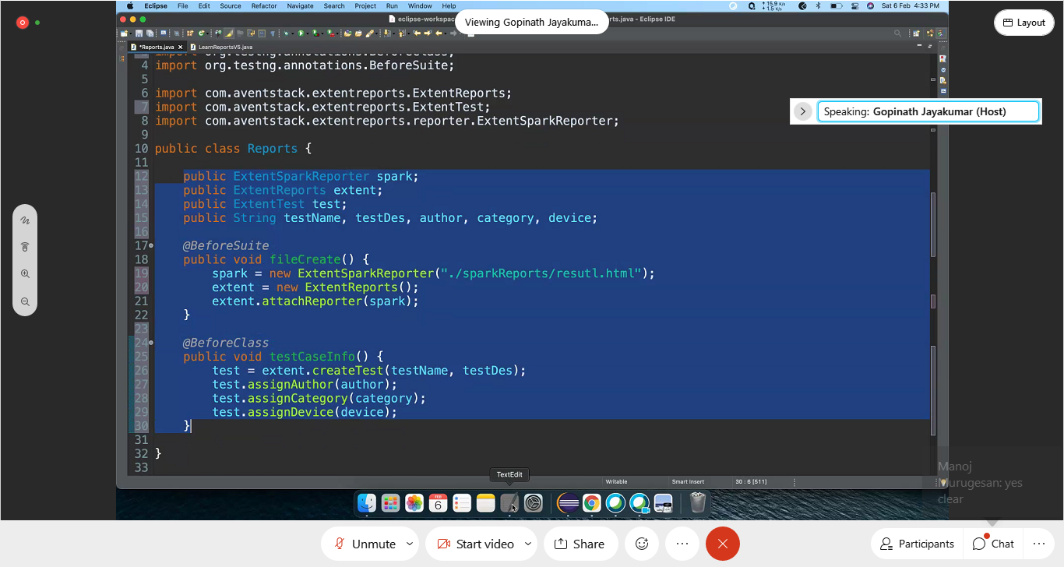

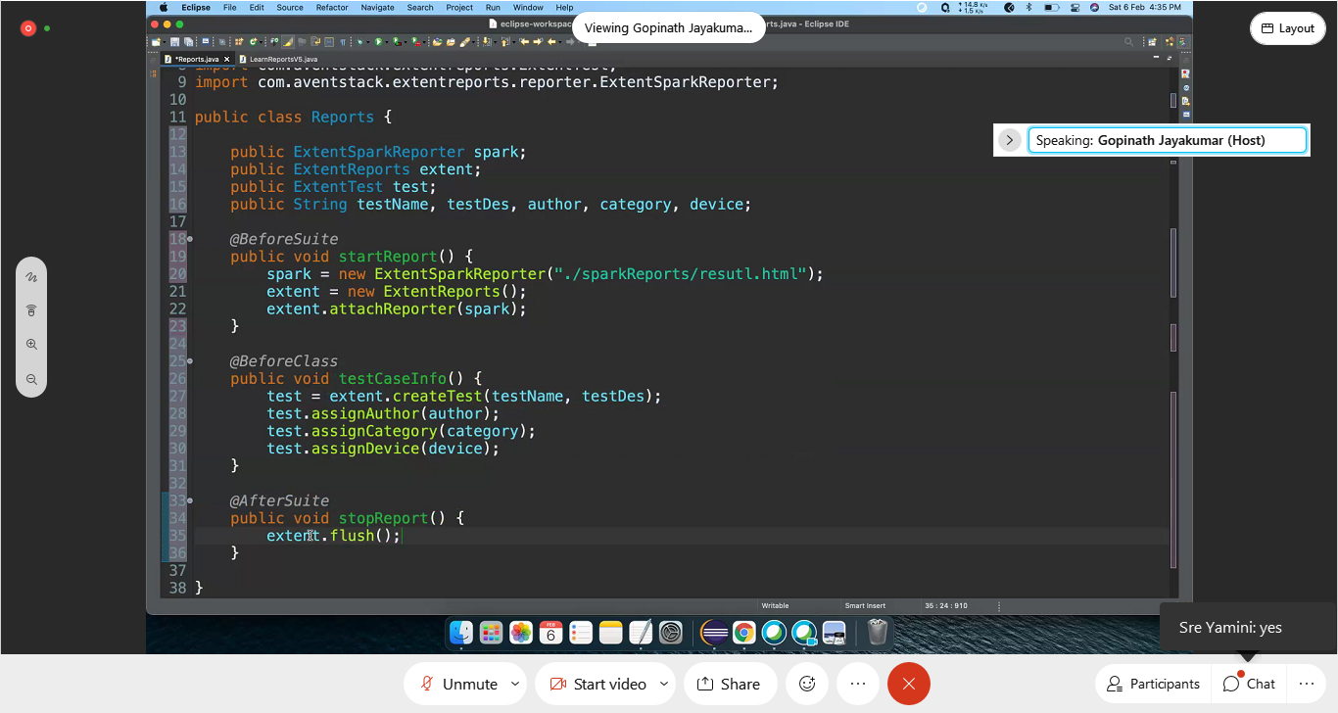

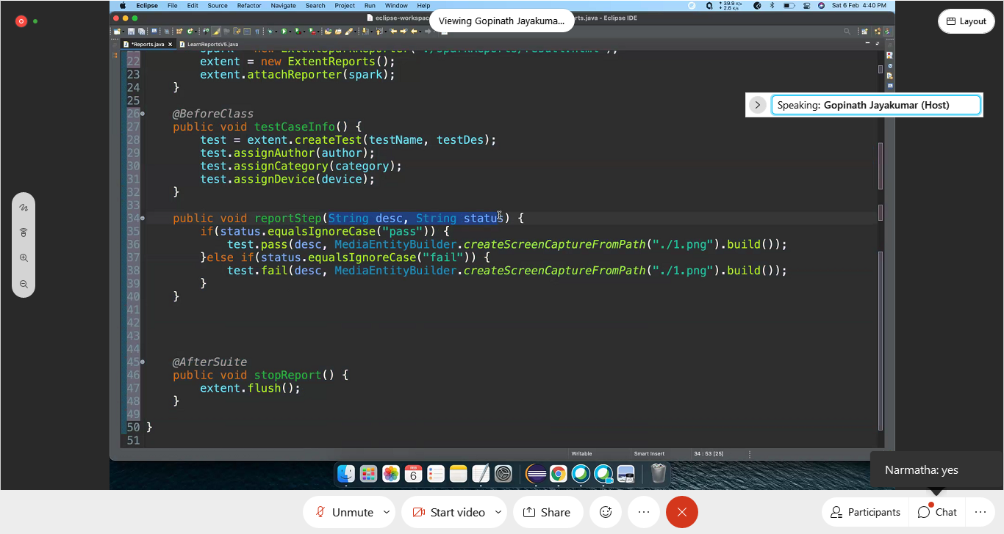

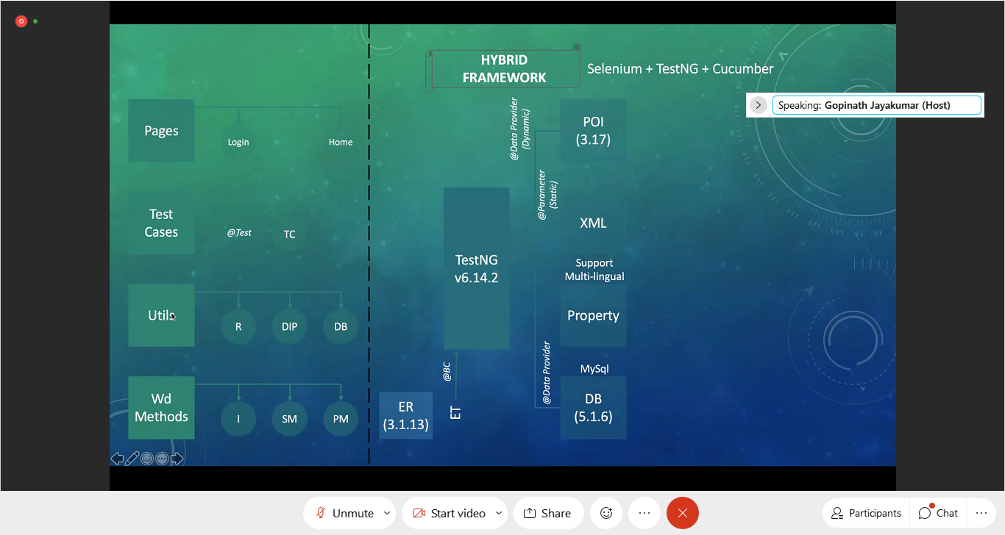

February session:

<dependency> <groupId>com.aventstack</groupId> <artifactId>extentreports</artifactId> <version>3.1.5</version>

</dependency>

